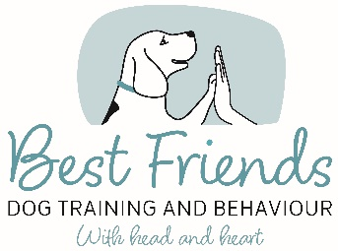

YIELD TO LEASH PRESSURE

Teach your dog that when the leash gets tight, he should give in to the pressure rather than pull against it. This skill will help with loose leash walking, greeting people and other dogs politely, and on occasions when your dog is excited by something in the environment. The sensation of the pressure on the leash becomes a cue for your dog to reorient to you.

STEP 1: Build an association
The first step is to build a positive association between the sensation of his harness being pulled, and yummy food.
- Stand or sit calmly with your dog on a short leash. ​
- Gently pull at the leash for a second or two, stop, and deliver a treat immediately. There’s no need to mark with a “Yes” or a clicker at this point. You’re simply pairing the two things together to create a positive emotional response.
- At this stage, your dog’s behaviour is irrelevant. Deliver the treat after adding pressure, no matter what your dog is doing.

Step 2: Entice your dog to move with the pressure
The next step involves some movement on your dog’s part.
- Pull very gently on the leash until your dog moves.
- The instant your dog moves in the direction of the pressure, mark and treat.
- Keep this easy! Be mindful not to get greedy at this point. A single step in the direction of the pressure is great and all that’s required.
- Do this several times until you feel your dog is responding more quickly to the pressure. You’ll know that has happened when it almost feels like you can’t practice this step anymore because your dog keeps moving with you!

Step 3: Add a stimulus and wait for your dog to orient towards you
Once your dog is consistently stepping into the direction of the pressure, you can add a stimulus in the immediate environment that your dog is interested in, like a toy or some food. Don’t use a person yet as that will be too difficult. Keep it easy at first and set your dog up for success.
- When he moves toward the item and the leash becomes taut, hang on to it firmly and wait for him to orient back toward you. Keep your hands close to your body and avoid "bungee arm" with your arm extended out. As soon as your dog orients towards you, mark and treat.
- Be patient and give him time to turn around on his own. You can stand still and wait for him to turn, or if you feel he’s a little too invested in the distraction, gently take a step back to create a little pressure that should entice him to turn toward you.
- Try to remain quiet, but if you feel the leash is taut for a little too long, make a kissy sound to grab his attention. When he turns and begins to move with you, mark and treat.
- If your dog is on his hind legs and pulling strongly toward the stimulus, you need to adjust the exercise to make it easier for him to reorient toward you. Either choose an item of less value or stand further away.
- Once he gets better at reorienting toward you from a farther distance, you can increase the level of difficulty by practicing closer to the stimulus, or by using a higher-value item.
- Remember that we want the sensation of the pressure to be the cue for your dog to reorient toward you, so as much as possible, remain quiet and let the pressure speak for you. (Use a kissy sound if things get difficult, and then adjust the exercise to make it easier next time.)​

